Import data :

mongo –db <DBName> –collection <CollectionName> –file <PATH>

mangodb --db iacsd0324 --collection movie --file C:\Users\user\Downloads\movie.json

1. Write a MongoDB query to display all the documents in the collection restaurants

→

db.samplerestaurant.find()

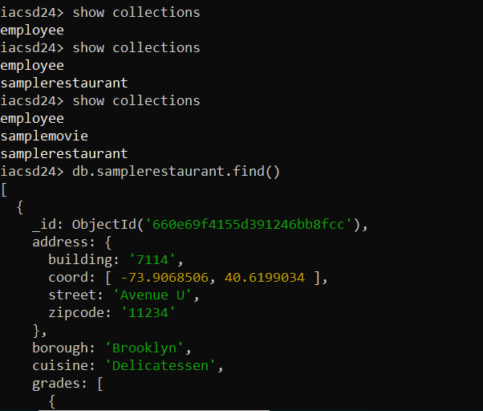

2. Write a MongoDB query to display the fields restaurant_id, name, borough and cuisine for

all the documents in the collection restaurant.

→

db.samplerestaurant.find({},{name:1,borough:1,cuisine:1})

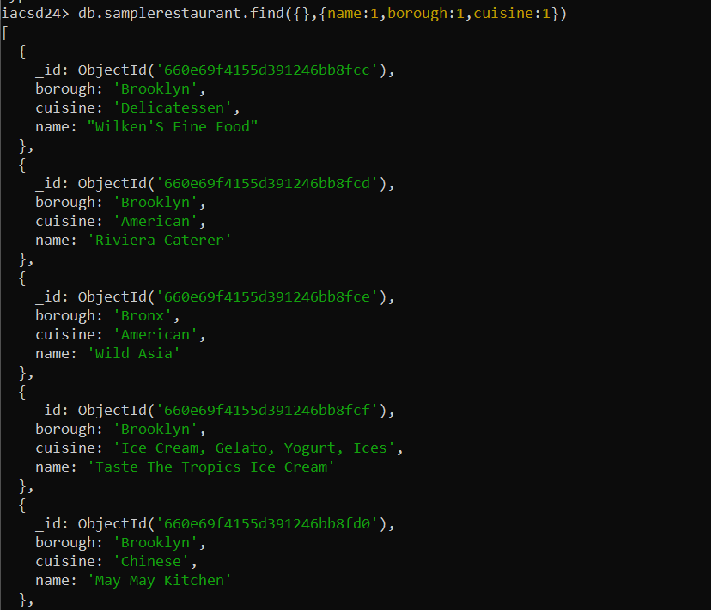

3. Write a MongoDB query to display the fields restaurant_id, name, borough and cuisine,

but exclude the field _id for all the documents in the collection restaurant.

→

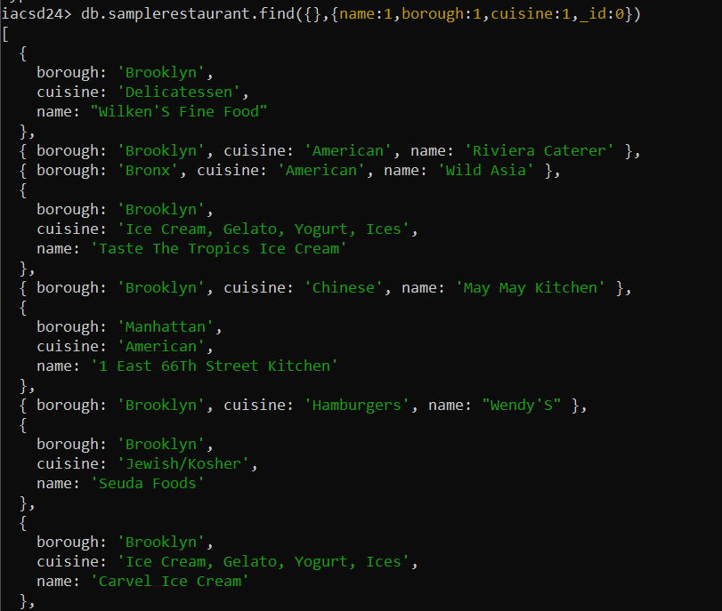

4. Write a MongoDB query to display the fields restaurant_id, name, borough and zip code,

but exclude the field _id for all the documents in the collection restaurant.

→

db.samplerestaurant.find({},{name:1,borough:1,zipcode:1,_id:0})

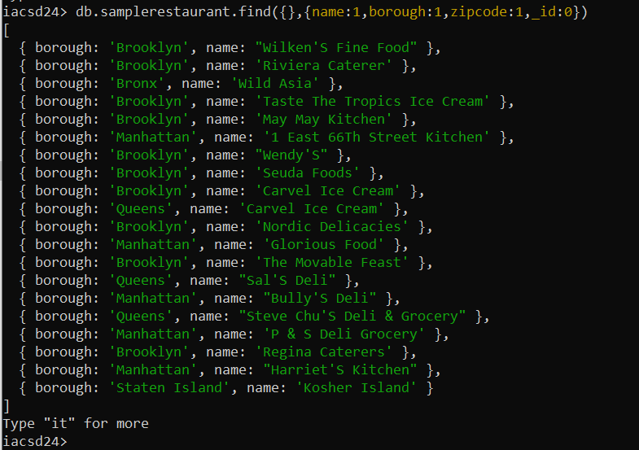

5. Write a MongoDB query to display all the restaurant which is in the borough Bronx

→

db.samplerestaurant.find({borough:'Bronx'},{name:1,borough:1,_id:0})

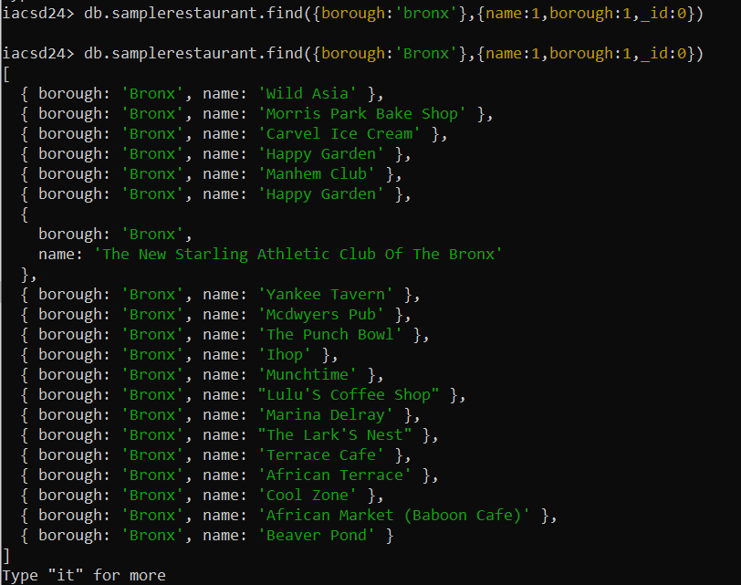

6. Write a MongoDB query to display the first 5 restaurant which is in the borough Bronx.

→

db.restaurent.find({borough:'Bronx'},

{name:1,borough:1,_id:0}).limit(5)

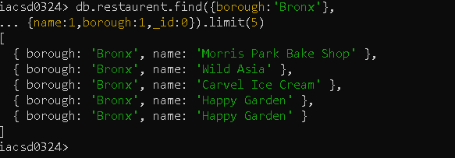

7.Write a MongoDB query to display the next 5 restaurants after skipping first 5 which are in

the borough Bronx.

→

db.restaurent.find({},

{name:1,borough:1,_id:0}).skip(5).limit(5)

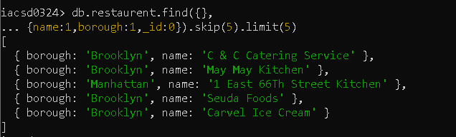

8. Write a MongoDB query to find the restaurants who achieved a score more than 90.

→

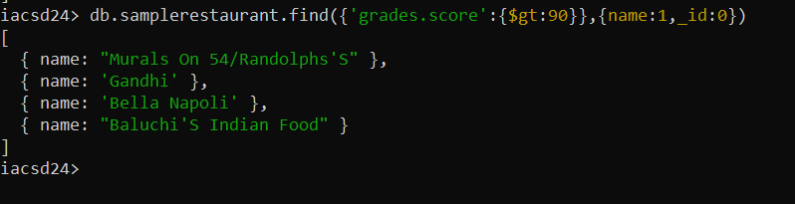

9. Write a MongoDB query to find the restaurants that achieved a score, more than 80 but

less than 100.

→

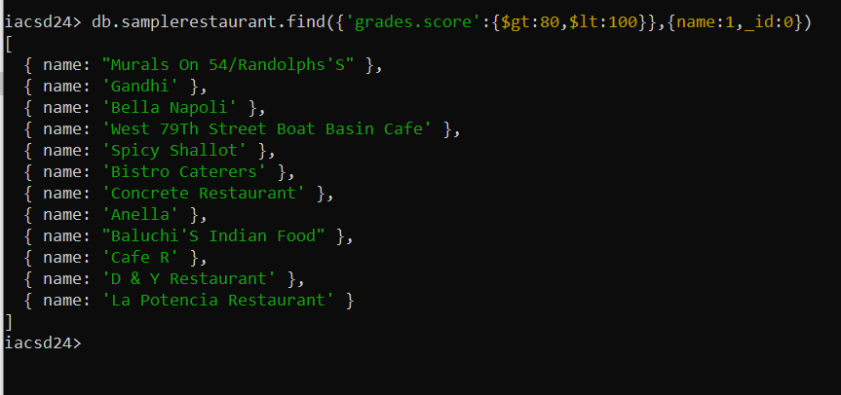

10. Write a MongoDB query to find the restaurants which locate in latitude value less than -

95.754168.

→

db.restaurant.find({'address.coord.1':{$lt:95.754168}},{name:1,'address.coord':1,_id:0})

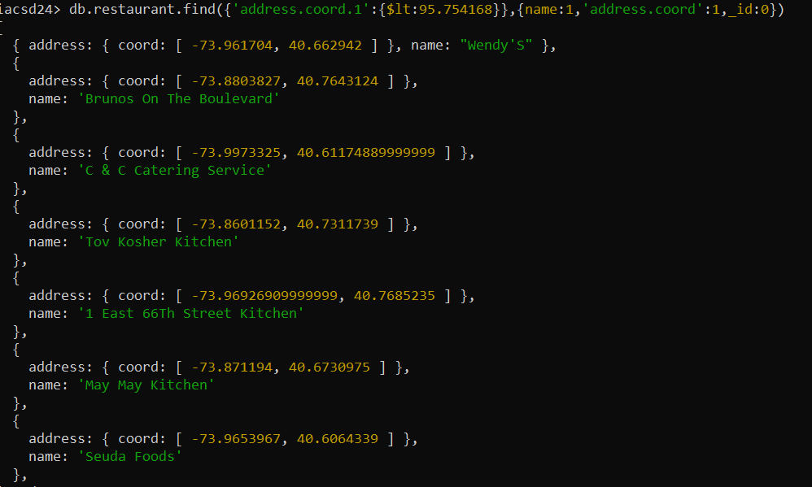

11. Write a MongoDB query to find the restaurants that do not prepare any cuisine of

'American' and their grade score more than 70 and latitude less than -65.754168.

→

db.restaurant.find({cuisine : {$nin :['American']},

'grades.score' : {$gt:70},

'address.coord.0':{$lt : -65.754168}},

{name : 1,'address.coord':1,'grades.score':1, _id:0})

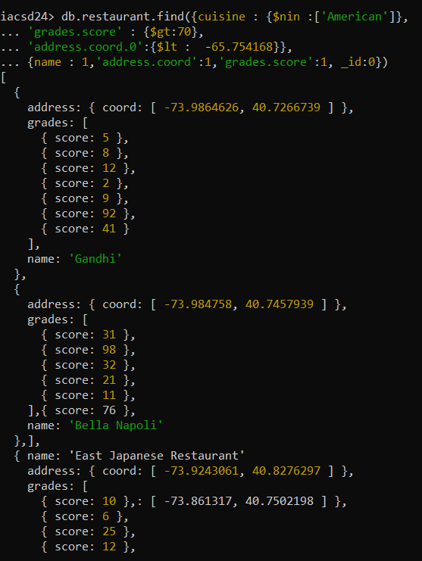

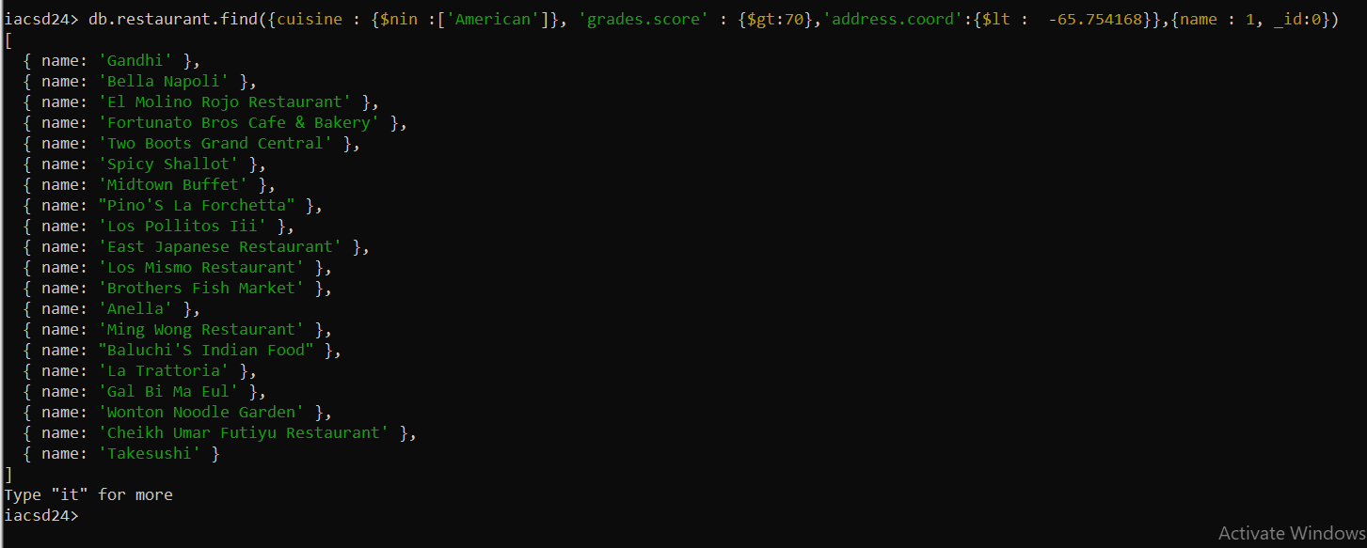

12. Write a MongoDB query to find the restaurants which do not prepare any cuisine of

'American' and achieved a score more than 70 and located in the longitude less than -

65.754168.

→

db.restaurant.find({cuisine : {$nin :['American']},

'grades.score' : {$gt:70},

'address.coord.1':{$lt : 65.754168}},

{name : 1,'address.coord':1,'grades.score':1, _id:0})

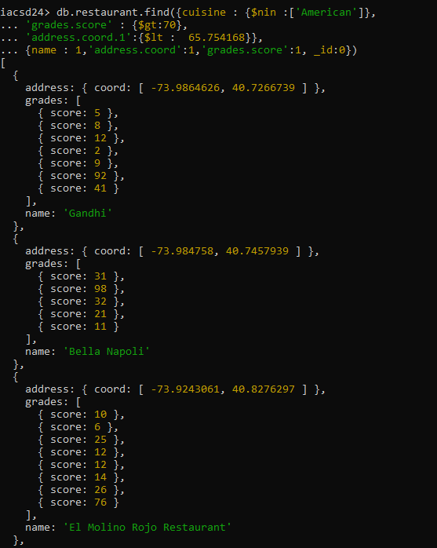

db.restaurant.find({cuisine : {$nin :['American']},

'grades.score' : {$gt:70},

'address.coord.1':{$lt : -65.754168}},

{name : 1,'address.coord':1,'grades.score':1, _id:0})

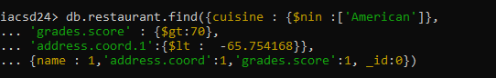

13. Write a MongoDB query to find the restaurants which do not prepare any cuisine of

'American ' and achieved a grade point 'A' not belongs to the borough Brooklyn. The

document must be displayed according to the cuisine in descending order.

→

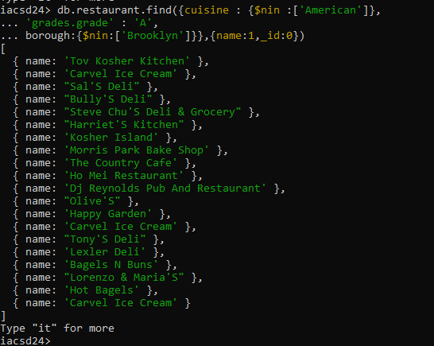

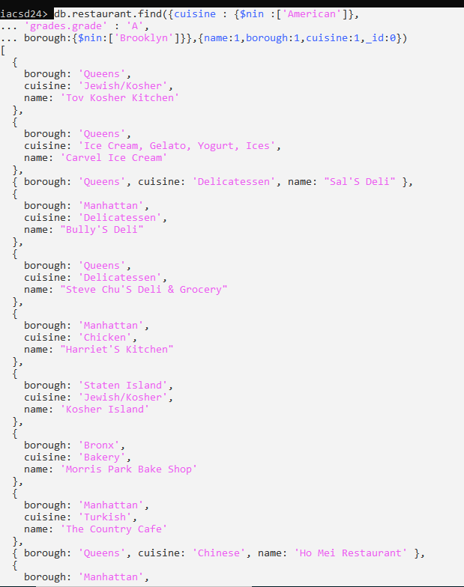

14. Write a MongoDB query to find the restaurant Id, name, borough and cuisine for those

restaurants which contain 'Wil' as first three letters for its name.

→

db.restaurant.find({name:/^wil/i},{name : 1, borough : 1, cuisine : 1})

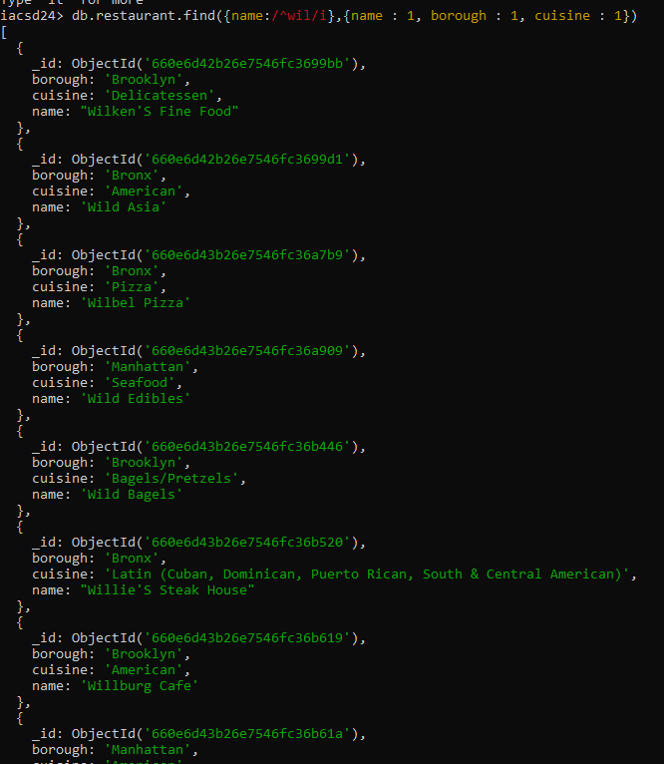

15. Write a MongoDB query to find the restaurant Id, name, borough and cuisine for those

restaurants which contain 'ces' as last three letters for its name.

→

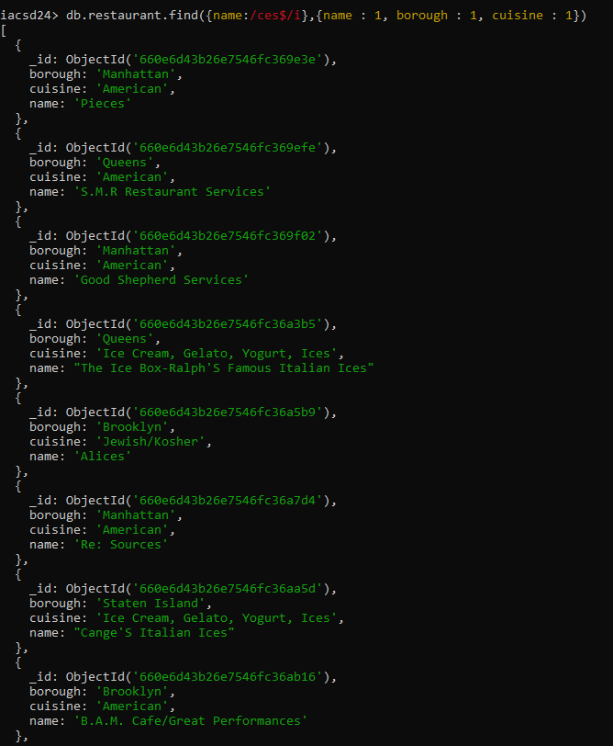

16. Write a MongoDB query to find the restaurant Id, name, borough and cuisine for those

restaurants which contain 'Reg' as three letters somewhere in its name.

→

db.restaurant.find({name:/reg/i},{name : 1, borough : 1, cuisine : 1})

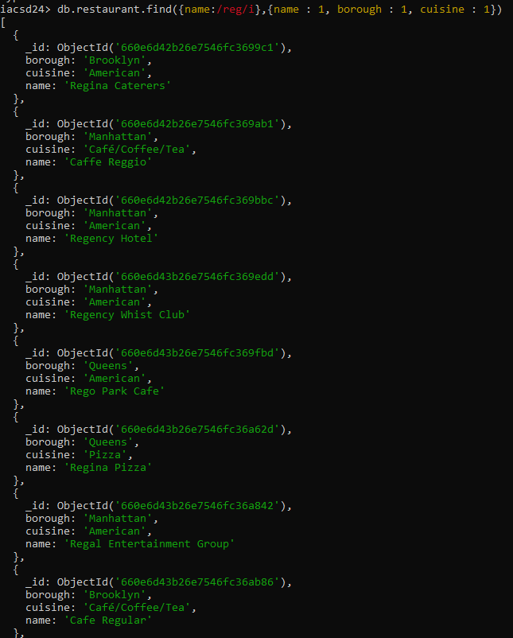

17. Write a MongoDB query to find the restaurants which belong to the borough Bronx and

prepared either American or Chinese dish.

→

db.restaurant.find({borough:'Bronx',cuisine:{$in:['American','Chinese']}},{name:1,borough:1,cuisine:1,_id:0})

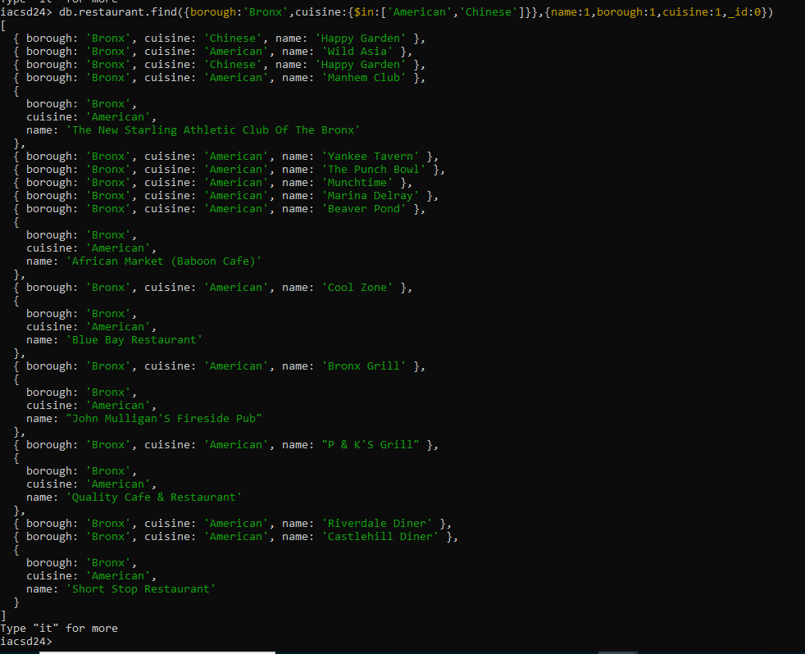

18. Write a MongoDB query to find the restaurant Id, name, borough and cuisine for those

restaurants which belong to the borough Staten Island or Queens or Bronxor Brooklyn

→

db.restaurant.find({$or:[{borough:{$in:['Staten Island','Queens','Bronx','Brooklyn']}}]},{name:1,borough:1,cuisine:1})

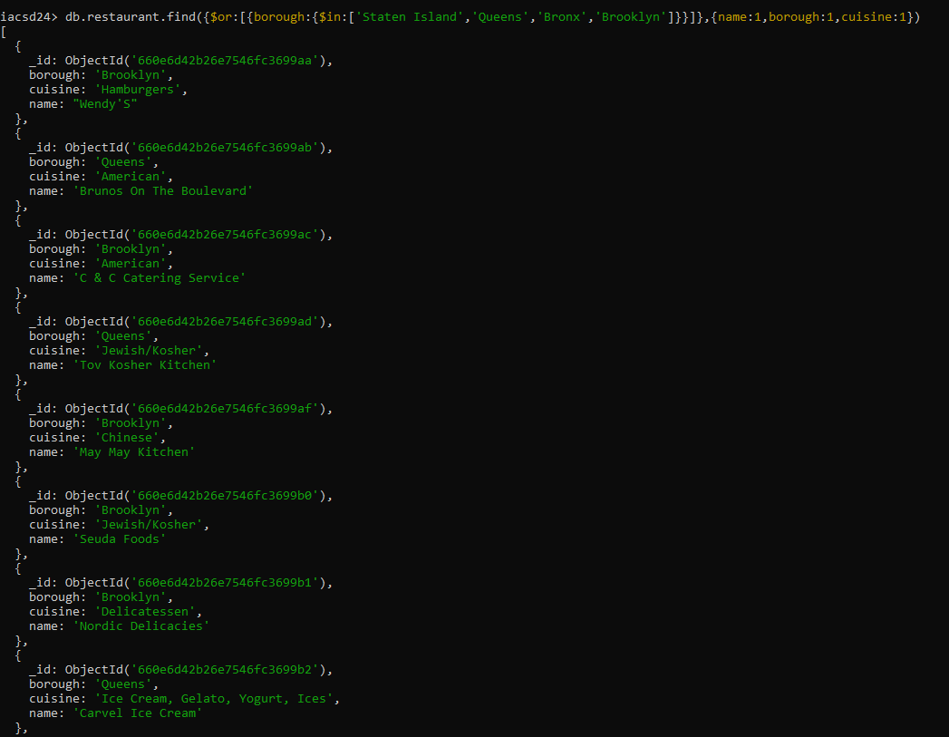

19. Write a MongoDB query to find the restaurant Id, name, borough and cuisine for those

restaurants which are not belonging to the borough Staten Island or Queens or Bronx or Brooklyn.

→

db.restaurant.find({$or:[{borough:{$nin:['Staten Island','Queens','Bronx','Brooklyn']}}]},{name:1,borough:1,cuisine:1})

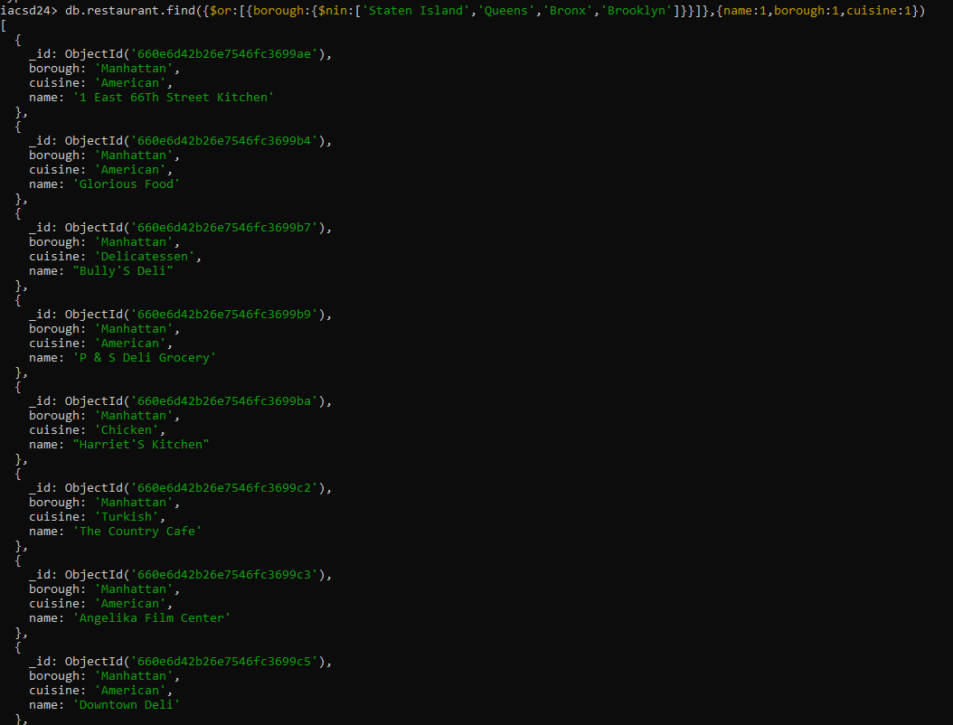

20. Write a MongoDB query to find the restaurant Id, name, borough and cuisine for those

restaurants which achieved a score which is not more than 10.

→

db.restaurant.find({'grades.score':{$not:{$gt:10}}},{name:1,borough:1,cuisine:1})

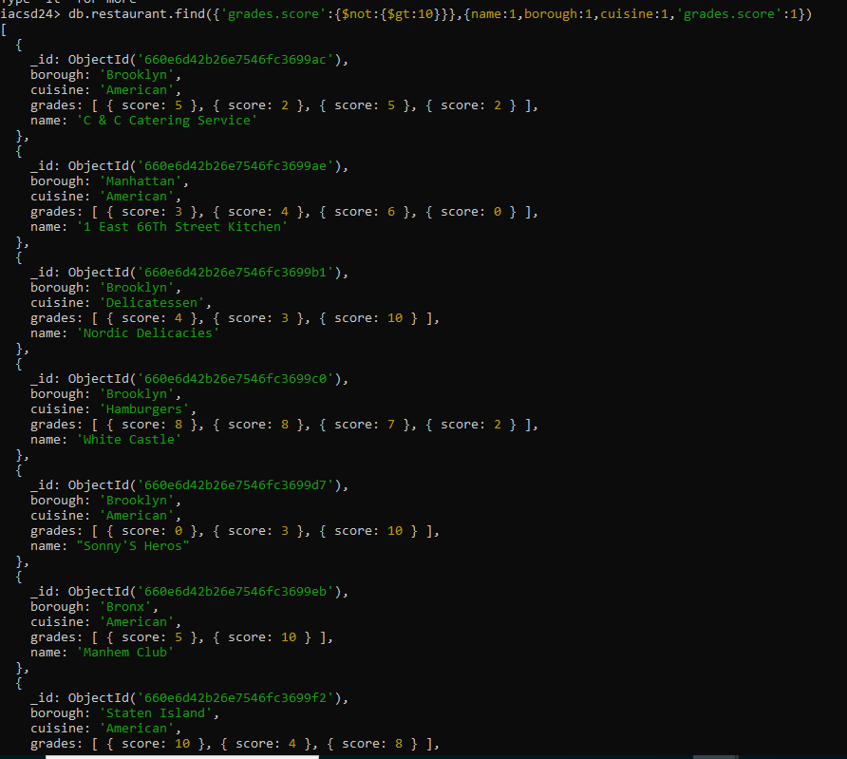

21. Write a MongoDB query to find the restaurant Id, name, borough and cuisine for those

restaurants which prepared dish except 'American' and 'Chinees' or restaurant's name begins

with letter 'Wil'.

→

db.restaurent.find({$or : [{cuisine : {$nin : ['American','Chinese']}},

{name : '/^wil/i'}]},

{name:1, borough:1, cuisine:1})

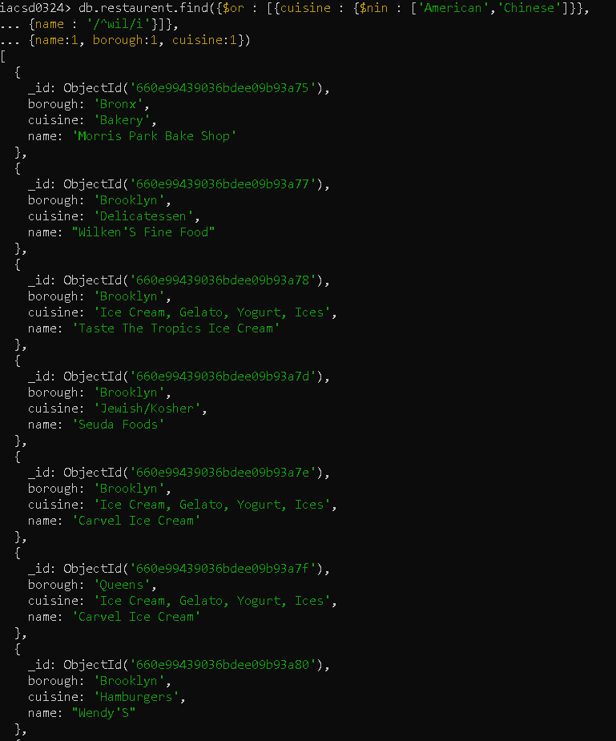

22. Write a MongoDB query to find the restaurant Id, name, and grades for those restaurants which achieved a grade of "A" and scored 11 on an ISODate "2014-08-11T00:00:00Z" among many of survey dates

→

db.restaurent.find({

grades : {$elemMatch:

{grade:'A',score:11, date:ISODate('2014-08-11T00:00:00Z')}}},

)

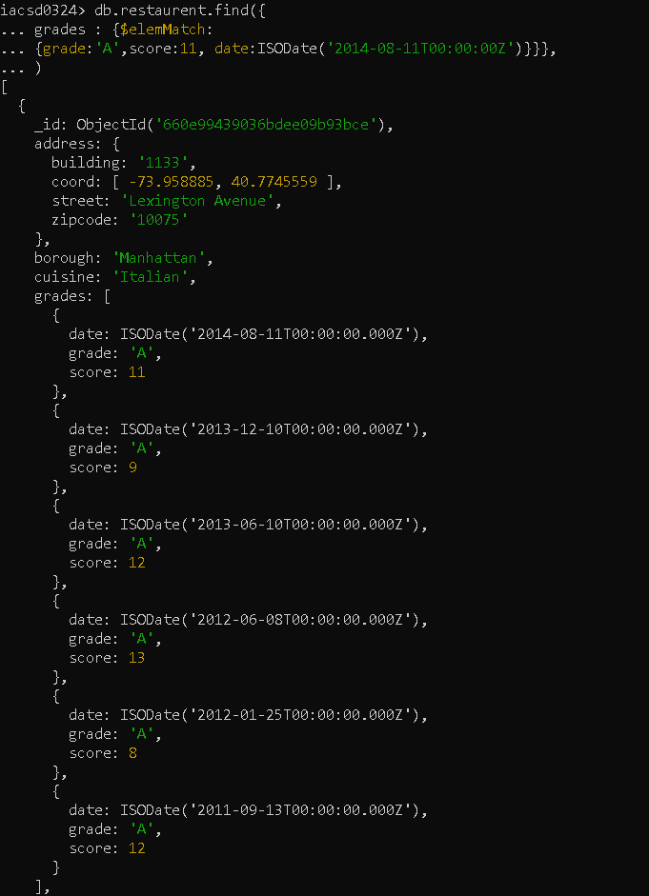

23. Write a MongoDB query to find the restaurant Id, name and grades for those restaurants

where the 2nd element of grades array contains a grade of "A" and score 9 on an ISODate

"2014-08-11T00:00:00Z".

→

db.restaurent.find({

'grades.1.grade':'A','grades.1.score':9,'grades.1.date':ISODate('2014-08-11T00:00:00Z')})

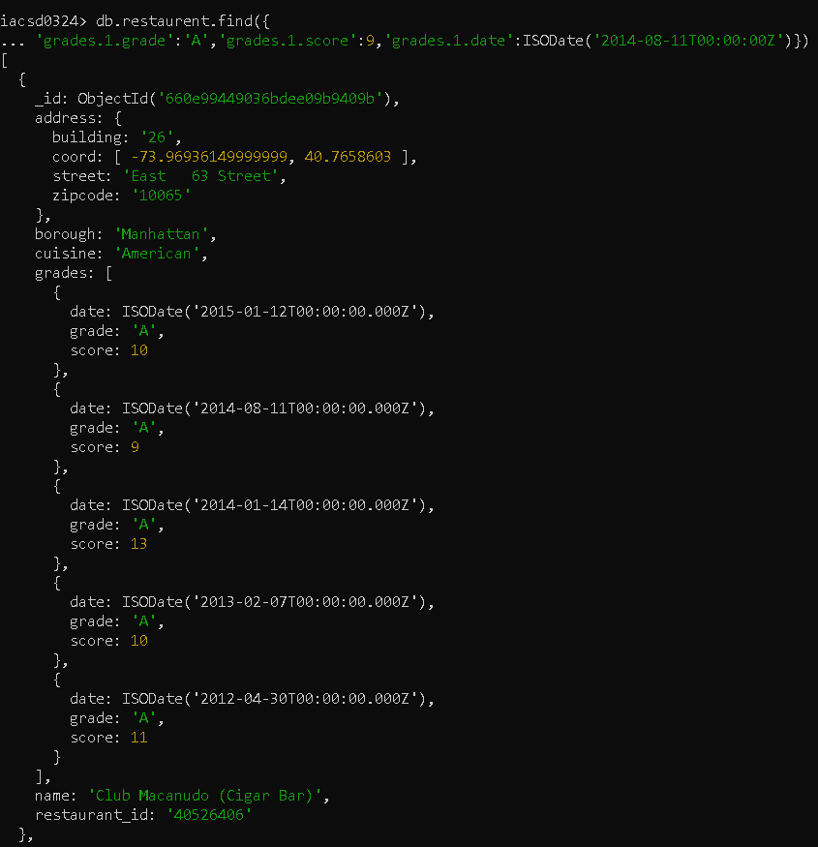

24. Write a MongoDB query to find the restaurant Id, name, address and geographical location for those restaurants where 2nd element of coord array contains a value which is more than 42 and upto 52

→

db.restaurent.find({'address.coord.1': {$gt:42,$lt:52}},

{name:1,address:1})

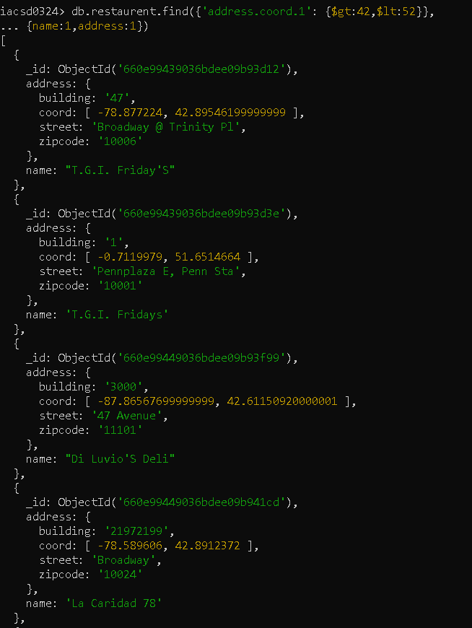

25. Write a MongoDB query to arrange the name of the restaurants in ascending order along with all the columns.

→

26. Write a MongoDB query to arrange the name of the restaurants in descending along with all the columns.

→

27. Write a MongoDB query to arranged the name of the cuisine in ascending order and for that same cuisine borough should be in descending order.

→

28. Write a MongoDB query to know whether all the addresses contains the street or not.

→

29. Write a MongoDB query which will select all documents in the restaurants collection where the coord field value is Double.

→

30. Write a MongoDB query which will select the restaurant Id, name and grades for those restaurants which returns 0 as a remainder after dividing the score by 7.

→

31. Write a MongoDB query to find the restaurant name, borough, longitude and attitude and cuisine for those restaurants which contains 'mon' as three letters somewhere in its name.

→

db.restaurent.find({name : /mon/i},

{name:1,borough:1,'address.coord':1,cuisine:1})

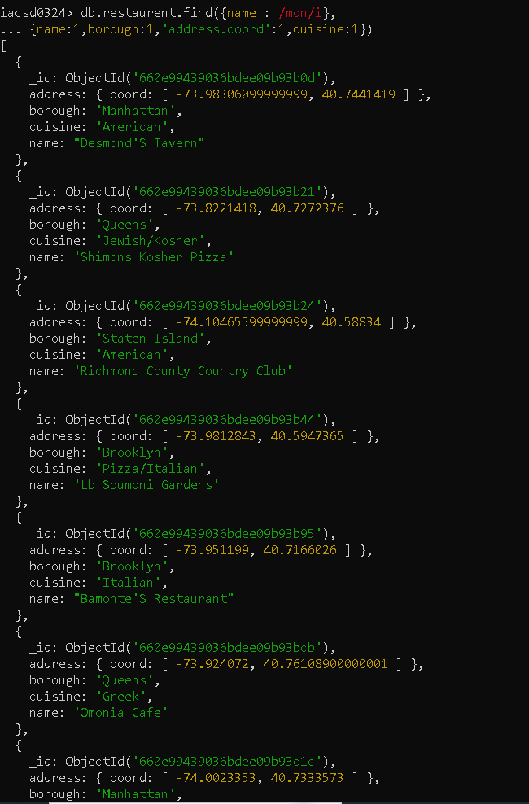

32. Write a MongoDB query to find the restaurant name, borough, longitude and latitude and

cuisine for those restaurants which contain 'Mad' as first three letters of its name.

→

db.restaurent.find({name : /^mad/i},

{name:1,borough:1,'address.coord':1,cuisine:1})

